Rows & columns

Insert or delete rows or columns
Small changes in the layout of your worksheet can give you big improvements in readability. Insert and delete rows, columns, and cells to organize your worksheet.
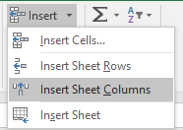
Insert a column
- Select the letter at the top of a column to select the column.
- Select Home > Insert > Insert Sheet Columns
Or, right-click the top of the column, and then select Insert.
Note: Excels inserts a new column to the left.
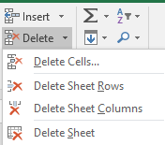
Delete a column
- Select the column.
- Select Home > Delete > Delete Sheet Columns.
Or, right-click the top of the column, and then select Delete.
Insert a row
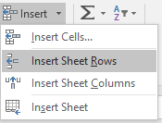
- Select the row number to select a row.
- Select Home > Insert > Insert Sheet Rows.
Or, right-click the selected row, and then select Insert.
Note: A new row is inserted above the selected row.
Delete a row
- Select the row.
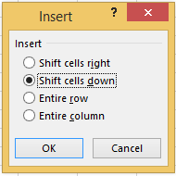
- SelectHome > Delete > Delete Sheet Rows.
Or, right-click the selected row, and then select Delete.
Insert a cell
- Select a cell or a cell range.
- Right-click the selected cells, and then select Insert.
- In the Insert box, select an option:
  - Shift cells right – shifts cells right to make space for the new cell(s).
  - Shift cells down – shifts cells down to make space for the new cell(s).
  - Entire row – inserts a new row.
  - Entire column – inserts a new column.
- Select OK.

Change the column width and row height
You can manually adjust the column width or row height or automatically resize columns and rows to fit the data.
Note: The boundary is the line between cells, columns, and rows. If a column is too narrow to display the data, you will see ### in the cell.
Resize rows
- Select a row or a range of rows.
- Select Format > Row Height.
- Type the row width and select OK.
Resize columns
- Select a column or a range of columns.
- Select Format > Column Width.
- Type the column width and select OK.
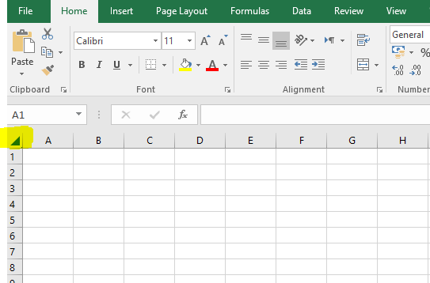
Automatically resize all columns and rows to fit the data
- Select the Select All button at the top of the worksheet, to select all columns and rows.
- Double-click a boundary. All columns or rows resize to fit the data.

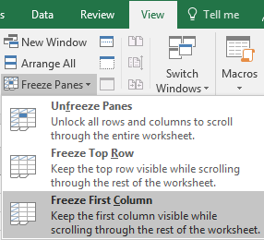
Freeze columns or rows
Freeze rows and columns to keep specific areas visible when you scroll in a worksheet.
Freeze the first column
- Select View > Freeze Panes > Freeze First Column.

The faint line that appears between Column A and B shows that the first column is frozen.
Freeze the first two columns
- Select the third column.
- Select View > Freeze Panes > Freeze Panes.
Freeze columns and rows
- Select the cell below the rows and to the right of the columns you want to keep visible when you scroll.
- Select View > Freeze Panes > Freeze Panes.

Hide or unhide columns
Hide or unhide columns in your spreadsheet to show just the data that you need to see or print.
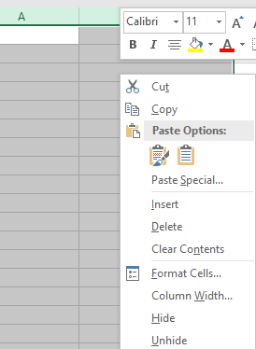
Hide columns
- Select one or more columns, and then press Ctrl to select additional columns that aren't adjacent.
- Right-click the selected columns, and then select Hide.
Note: The double line between two columns is an indicator that you've hidden a column.
Unhide columns
- Select the adjacent columns for the hidden columns.
- Right-click the selected columns, and then select Unhide.
Or double-click the double line between the two columns where hidden columns exist.

Split and combine data
You can take the text in one or more cells, and split it into multiple cells using the Convert Text to Columns Wizard.
- Select the cell or column that contains the text you want to split.
- Select Data > Text to Columns.
- In the Convert Text to Columns Wizard, select Delimited > Next.
- Select the Delimiters for your data. For example, Comma and Space. You can see a preview of your data in the Data preview window.
- Select Next.
- Select the Column data format or use what Excel chose for you.
- Select the Destination, which is where you want the split data to appear on your worksheet.
- Select Finish.

